Stable Marriage Problem

For this assignment, you may work in pairs. There will be one or two other projects (including the final project) that can be done in pairs. No two projects may be done with the same pair.

This assignment is to write a GUI-based program to solve the Stable Matching Problem using the Gale-Shapley algorithm. The program must adhere to the posted “Coding Guidelines - Linear DS.doc”.

See the posting “Stable Matching.ppt” in the Algorithms folder. There are also numerous references to the Gale-Shapley algorithm on the Internet.
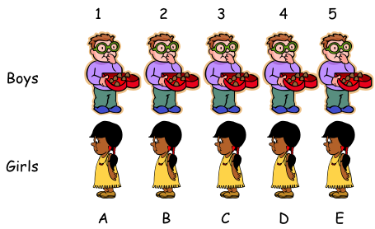

The input to the program will be a text file listing, in order,
- the number n of men and women,
- the names of the n men,
- the names of the n women,
- the list of preferences for the n men, and
- the list of preferences of the n women.
For example, consider the following example of the contents of a file
----------------------------------------------------
5
Brian George John Robert Stephen
Anne Joyce Nancy Patricia Susan

// Preferences Men:

John: Susan Joyce Nancy Patricia Anne

Robert: Nancy Anne Joyce Susan Patricia

Brian: Patricia Susan Joyce Anne Nancy
Stephen: Joyce Anne Susan Nancy Patricia

George: Nancy Joyce Patricia Susan Anne

// Preferences Women:

Nancy: John Brian Stephen Robert George

Joyce: George John Stephen Robert Brian

Patricia: George Brian Robert Stephen John
Anne: George Stephen John Brian Robert
Susan: Brian George Stephen John Robert
----------------------------------------------------

The output will be two lists of arranged marriages, one where the men propose, and one where the women propose.
----------------------------------------------------

Marriages:
(Anne,Stephen)
(Joyce,George)
(Susan,John)
(Patricia,Brian)
(Nancy,Robert)
----------------------------------------------------

The program will operate as follows:
- Ask the user for the name of the input file
- Display the number of men and women, and the lists of men and women
- Display the list of men’s preferences in one window, the women’s preferences in another
- Display a pair of radio buttons for the user to select one of the following:
Men Propose
Women Propose
- Display a button to click in order to apply the Gale-Shapley algorithm
- Display the 2 lists of marriages and a button to close the program

Be sure to see the posted document “Printed Submission of Projects.doc“. The submission should include a printout using the data given above. In addition to submitting a complete working program, your grade will be based on how well the program satisfies the given guidelines.

